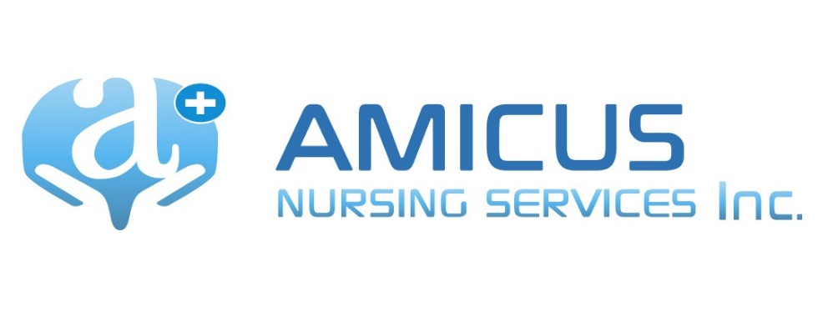
Hiring of Nurses

POLICY:
Amicus Nursing Services, Inc will check references, verify identity, and verify eligibility to work in the United States. Nurses shall complete all screening requirements prior to first assignment.

PURPOSE:
To hire and retain qualified personnel in compliance with regulatory standards.

PROCEDURE:
- All applicants will be informed of Amicus hiring, onboarding, and placement requirements during the screening process.

- Qualified applicants for employment with Amicus as a RN may be extended a contingent offer of employment, pending confirmation of successful completion of the Amicus screening requirements.

- The screening process shall include, at a minimum:
  - Resume / Application
  - Criminal background check
  - Drug testing
  - Verification of current licensure
  - Verification of BLS certification and any other applicable certifications
  - Physician health statement including proof of recent negative PPD (within 12 months of date of hire) or recent chest x-ray
  - Proof of Hepatitis B vaccine or signed declination
  - Reference checks (at least 2)
  - Other qualifying documentation as required by state law

- Formal employment offer shall be extended after applicant has successfully completed the employment credentialing process.

- Each RN personnel file shall contain:
  - Application / Resume
  - References
  - Criminal background check
  - I-9
  - Skills / Competency checklist
  - Current professional license
  - BLS certification
  - Health Statement and Immunizations
  - Drug testing
  - Independent contractor agreement
  - Proof of malpractice insurance (in amount of $1,000,000 / 6,000,000)
  - Direct deposit form
  - Onboarding checklist
  - Annual Performance Evaluation

